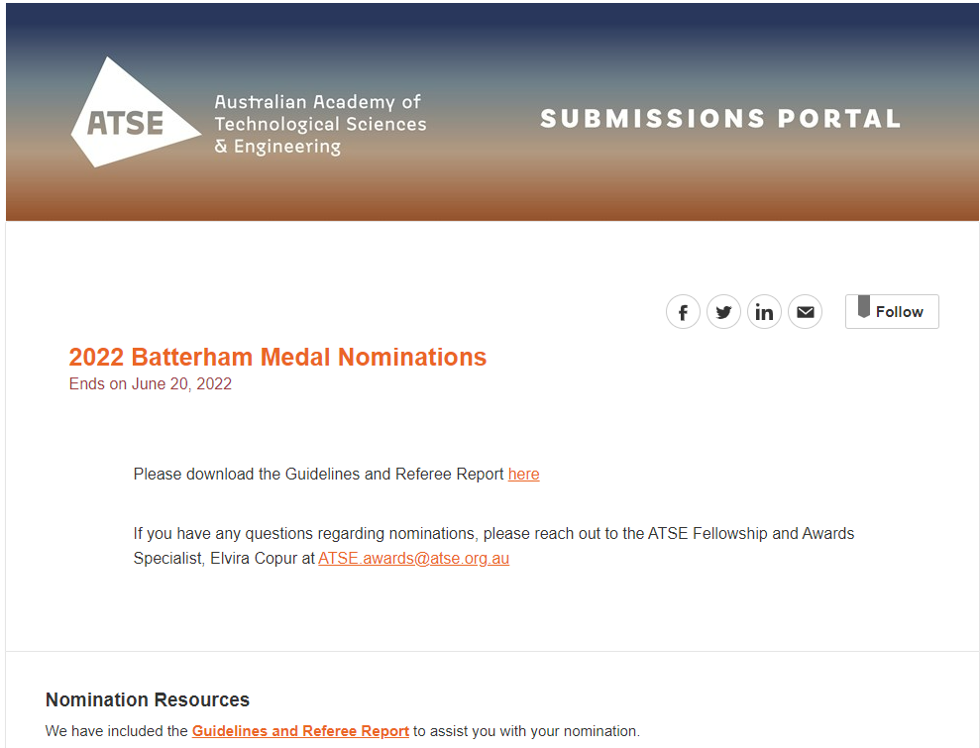
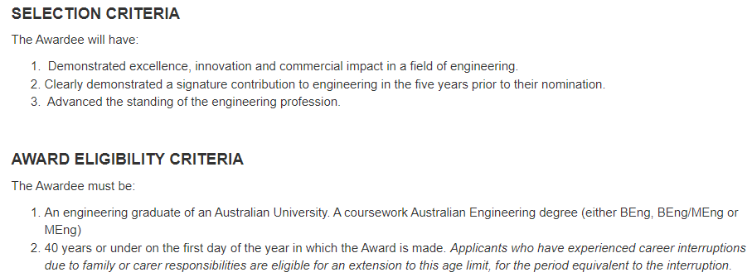

Proposer, Nominee and Seconder Details
Proposer Name
First Name

Last Name

Proposer Organisation

Proposer Position

Proposer Address

Country

Address

Address Line 2 (optional)

City

State

Postal Code

Proposer Email

Proposer Mobile Phone

Nominee Name
First Name

Last Name

Gender

Does the nominee identify as Aboriginal or Torres Strait Islander?

Nominee Date of Birth

Nominee Organisation

Nominee Position

Nominee Address

Country

Address

Address Line 2 (optional)

City

State

Postal Code
Nominee Email

Nominee Mobile Phone

Seconder Name
First Name

Last Name

Seconder Organisation

Seconder Position

Seconder Address

Country

Address

Address Line 2 (optional)

City

State

Postal Code

Seconder Email
Seconder Mobile Phone

PART B: EXECUTIVE OVERVIEW – Limit 100 words
(for Citation purposes: please use plain English suitable for a broad audience)

PART C: AWARD SELECTION CRITERIA

Selection Criterion 1: Excellence, Innovation and Impact in a field of engineering
Please outline, using clear, quantifiable and verifiable examples, how the nominee has achieved Excellence, Innovation and Impact. This section must clearly demonstrate that a nominee has applied new or existing engineering practices to practical effect and has been able to work productively with end users. It must also include examples of individual impact, as distinct from that of a company, institution or organisation. Listing of a nominee’s career positions and achievements, without detailed and preferably quantified presentation of impact, is insufficient. - Limit 500 words

Selection Criterion 2: Signature contribution to engineering in the five years prior to nomination
The nomination should provide information on:
- Nominee’s signature contribution to their field of engineering
- Evidence of the impact of the nominee in their field of engineering
Limit 500 words

Selection Criterion 3: Advanced the standing of the engineering profession
Please outline, using tangible examples, how the nominee has advanced the standing of the engineering profession - Limit 500 words

PART D: AWARD ELIGIBILITY CRITERIA

- Eligibility Criterion 1: Engineering Graduate of an Australian University
The nomination should attach legally certified evidence of graduation from an Australian university. a coursework Australian Engineering degree (either BEng, BEng/MEng or MEng)
Note: PDF letter or certificate must have been issued by Australian university.

- Eligibility Criterion 2: Age
The nominee is to be 40 years or under on the first day of the year in which the Award is made:
- 2022 Batterham Medal: age 40 years or under on 1 January 2022
Applicants who have experienced career interruptions due to family or carer responsibilities as eligible for an extension to this criterion, for the period equivalent to the interruption. Please attach legally certified evidence of age (eg Birth Certificate / Driver’s Licence (issued by an Australian State or Territory)/Passport and (if applicable) evidence of career interruptions in the form of a letter from the nominee’s employer(s) clearly stating the length and nature of the interruption.

PART E: SECONDER LETTER
The Seconder is to provide a letter of no more than two A4 pages in length, clearly indicating their detailed knowledge of the work for which the nomination has been made, and how this work satisfies the selection criteria.

PART F: REFREE REPORT
The Proposer should include a Referee Report from an industry or technical expert in the nominee’s field on the separate form provided (note Referee Reports are confidential).

PART G: NOMINEE STATEMENT OF CONSENT
The nominee has read the terms and conditions for the ATSE Awards and agree that, as a condition of them being nominated, they permit the release of all materials that I have submitted for the purposes of the selection process.
Furthermore, in the event of their receipt of the ATSE Award, they agree to:
• Attend the award ceremony in 2022 (details to be advised)
• Participate in activities as reasonably requested by ATSE within 12 months of receiving the award.
• Work with ATSE secretariat and Fellows to promote the importance of the award.
They also understand that in the event of being awarded the Award, a description of the work being acclaimed and images of themselves will be publicised, and they may be called upon to speak at events or to the media.

Nominations close 5pm AEST Monday 20 June 2022.
If you have any questions regarding the process, please don't hesitate to reach out to Elvira, Fellowship and Awards Specialist at atse.awards@atse.org.au

