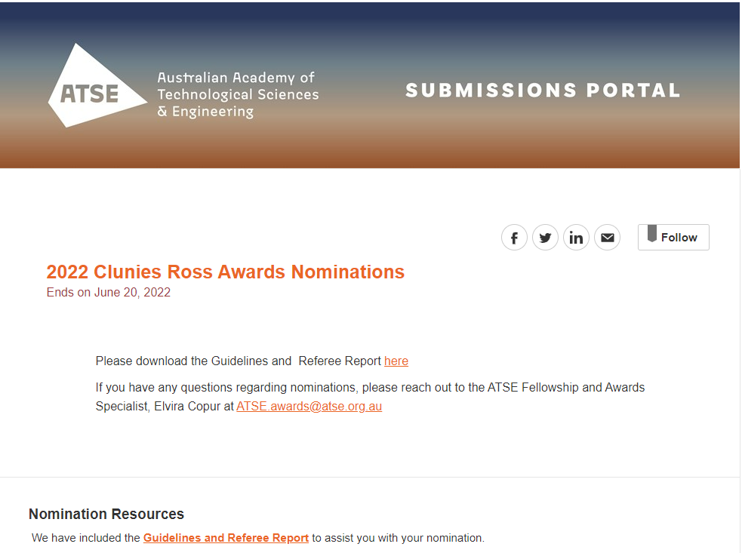
PART A - Proposer and Nominee Information

Proposer Name
First Name

Last Name

Company

Position

Address

Country

Address

Address Line 2 (optional)

City

State

Postal Code

Email *

Mobile Phone*

Nominee Name
First Name

Last Name

Company

Position

Address

Country

Address

Address Line 2 (optional)

City

State

Postal Code

Email

Mobile Phone

Gender

Does the nominee identify as Aboriginal or Torres Strait Islander?

PART B: Application Overview – Limit 250 words
Please provide a summative statement that highlights this individual's qualifications
PART C: Selection Criteria
Criterion 1: Contribution and application
- A description of the product or license or technology involved, its nature, its name or designation and how it is protected through patents, know how or trade secrets. The description should include details of the beneficial/commercial owner and the relationship to the nominee(s) if they are not the same.
- A description of the outcome and the impact the contribution has made and in what field. The history and status of the contribution from the date it was first defined to the present, including the date when it became a commercial reality, achieved broad market acceptance or was widely used in the community, should be included.
- Evidence of the nature of the contribution demonstrating entrepreneurship, knowledge commercialisation, and innovation. A clear outline of the personal involvement of the nominee(s) through all stages from discovery to commercial application is important here. It is not expected that all three aspects of entrepreneurship, commercialisation and innovation are equally important in the nomination.
- If patents protect the invention, evidence should be provided to show the nominee(s) role.
It is important that in this section, persistence is demonstrated (this may be over a considerable period). View this as evidence of ‘going the extra mile’ – evidence of the continuity of involvement of the nominee(s) from discovery through the creation of the product and its successful and sustainable commercial application. It is recognised that others will have been involved during this process as specialists, but the nominee(s) must have had the leading and decisive role throughout, as substantiated by the evidence in the nomination.
Statement: Contribution and application - Limit 500 words

Criterion 2: Demonstration of impact
- Impact is understood in broad terms:
Where the main outcome has been the commercialisation of a product(s) or technology into a defined marketplace provide details of sales, the impact on the market and the relevance to competitive position going forward.
Where the outcome has been the licensing of technology into the marketplace: Financial details of the license plus details on the uptake of the technology as a result of the license
And/or where the outcome is measured as significant social or environmental benefit to Australia it is important to provide estimates as to the magnitude of that benefit in terms of cost savings or other tangible and verifiable outcomes, including the extent to which the contribution has been widely adopted.
Verifiable evidence that could be brought to bear under impact include
- Financial: details of sales, financial details of licenses, financial impact as a result of uptake of the technology.
- Jobs: jobs created, transformed (Up skilled) or secured (avoided job loss), with preference to Australian jobs.
- Productivity: productivity improvement, evidence of added value to product or process.
- Competitiveness: improved position in global supply chain, evidence of impact on the market.
- Sustainability: evidence of long-term impact to an industry, user service or product that is transformative to existing processes.
- Social Impact: evidence that the impact is sustainable including evidence of impact in the areas of health, safety, environment, compliance and community impact; improvement for an identified subset of the community, or a previously unmet need.
Statement: Demonstration of impact – Limit 500 words

Criterion 3: Advancement of technology
- Evidence of the nominee’s outstanding record of commitment to successful innovation involving the application of science, technology and engineering to the economic, and social or environmental benefit of Australia. Excellence in research is not sufficient.
- Evidence that the nominee/initiative has had a profound impact on the cultural environment within organisations such as public funded research bodies/ universities or industry.
- Evidence of mentorship, going the extra mile in terms of developing a next generation of science, technology and engineering led innovators and entrepreneurs.
Statement: Advancement of technology – Limit 500 words

PART D: Proposer Overview – Limit 500 words
The nominator should provide information on the reasons why you consider the nominee(s) is worthy of an Award and a summary of how the criteria outlined in Part C Selection Criteria section of the nomination form are satisfied

PART E: REFEREE INFORMATION
Referees should be knowledgeable of the Nominee’s achievements but independent of the nominee’s contributions. Referees need to identify their link to the Nominee as appropriate.
Referees MUST submit their supporting documentation using the official Referee Report form and return their completed form to the Nominator for uploading into the Nomination Portal by 5pm AEST Monday 20 June 2022.

Referee 1 Name
First Name

Last Name

Company

Position

Email

Mobile Phone

Referee 2 Name
First Name

Last Name

Company

Position

Email

Mobile Phone

PART F: NOMINEE SUPPORTING DOCUMENTS
A maximum of five supporting documents (including a CV document) are permitted per nomination. A nominator can upload into the Nomination Portal supporting documents such as:
- Quantitative documentation, for example a company Annual Report
- Referee Reports (completed on the official Referee Report Form)
- Nominee’s CV (no more than two pages per person)
- Links to published patents, or patent submissions
- Any external acknowledgement of inventorship
- Financial details of sales, or licenses, and/or clearly identified financial impact as a result of uptake of the technology.
- Jobs created, or transformed (up skilled) or secured (avoided job loss), with preference to Australian jobs as part of the impact
- Productivity: productivity improvement, evidence of added value to product or process
- Competitiveness: improved position in global supply chain, evidence of impact on the market
- Sustainability: Evidence that the impact is sustainable and transformative.
- Social Impact: evidence of impact in the areas of health, safety, environment, compliance and community impact; improvement for an identified subset of the community; or a previously unmet need
- Evidence of other external recognition.

Supporting Documents
Acceptable file types: .doc, .docx, .pdf

PARTG: Referee Reports
Acceptable file types: .doc, .docx, .pdf

Nominations close 5pm AEST Monday 20 June 2022.
If you have any questions regarding the process, please don't hesitate to reach out to Elvira, Fellowship and Awards Specialist at atse.awards@atse.org.au

