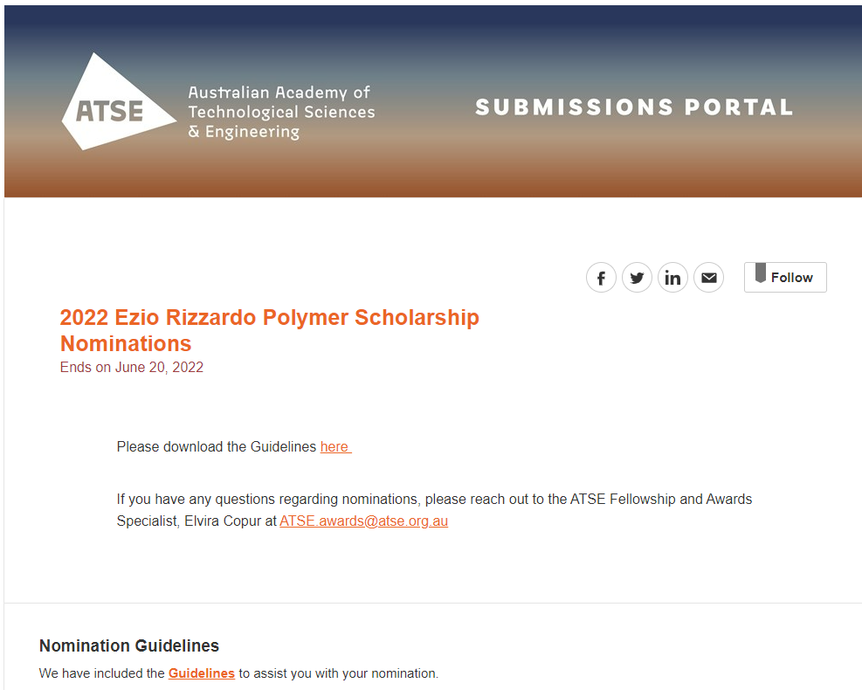
Proposer, Nominee and Supervisor Details
Proposer Name
First Name

Last Name

Proposer Organisation

Proposer Position

Proposer Address

Country

Address

Address Line 2 (optional)

City

State

Postal Code

Proposer Email

Proposer Mobile Phone

Nominee Name
First Name

Last Name

Gender

Does the nominee identify as Aboriginal or Torres Strait Islander?
Nominee Date of Birth

Nominee Organisation

Nominee Position

Nominee Address

Country

Address

Address Line 2 (optional)

City

State

Postal Code

Nominee Email

Nominee Mobile Phone

Supervisor Name
First Name

Last Name
Supervisor Organisation

Supervisor Position

Address

Country

Address

Address Line 2 (optional)

City

State

Postal Code

Email

Mobile Phone

PART B: EXECUTIVE OVERVIEW – Limit 100 words
(for Citation purposes: please use plain English suitable for a broad audience)

PART C: ELIGIBILITY CRITERIA

Criterion 1: A student of one of the 14 participant universities
Nominee’s Official Academic Transcript
The nomination should attach legally certified evidence of enrolment from participant Australian university.
Note: PDF letter or certificate must have been issued by the Australian university.

Criterion 2: An Australian citizen or Australian permanent resident
legally certified PDF evidence of Australian citizenship or Australian permanent residency

PART D: PROPOSER STATEMENT
The Proposer must be a Dean of Engineering or Dean of Science at an eligible university. The Proposer should provide information on the reasons why you consider the nominee is worthy of the Ezio Rizzardo Polymer Scholarship, providing examples to illustrate the following criteria:
- How does the nominee demonstrate excellence in their undergraduate degree?
- How does the nominee demonstrate ability to effectively communicate scientific ideas and accomplishments to a broad audience?
- How does the nominee’s research proposal have the potential to make a high impact contribution to applied polymer science or engineering?
Limit 500 words

PART E: RESEARCH PROPOSAL
must include the following:
- Project title
- Aim - one sentence
- Background - the nature and scale problem you are addressing, the best technologies currently available to address this and their shortcomings
- Research – your scientific approach, what you will do, and why it is novel, and the major milestones you will achieve during the PhD
- Path to Impact– a brief description of how the outcomes of your research will deliver impact and the potential benefits it may provide.
Limit 500 words

PART F: SUPERVISOR STATEMENT
Provide a more detailed case against the selection criteria for why their student would be an excellent recipient of the scholarship.
Limit 200 words

PART G: NOMINEE STATEMENT OF CONSENT
The nominee has read the terms and conditions for the ATSE Awards and agree that, as a condition of them being nominated, they permit the release of all materials that I have submitted for the purposes of the selection process.
Furthermore, in the event of their receipt of the ATSE Award, they agree to:
• Attend the award ceremony in 2022 (details to be advised)
• Participate in activities as reasonably requested by ATSE within 12 months of receiving the award.
• Work with ATSE secretariat and Fellows to promote the importance of the award.
They also understand that in the event of being awarded the Award, a description of the work being acclaimed and images of themselves will be publicised, and they may be called upon to speak at events or to the media.

NOMINEE’s CV
must include the following:
- a list all publications and presentation to date, and their other communication activities (e.g., STEM advocacy, mentoring)
- relevant vacation and work experience
- other extra curricula activities that may also be considered important for the award, e.g., involvement on committees or in clubs and societies, and
- any additional skills and competencies, e.g., languages, sporting or musical achievements, etc.
Maximum two pages

Nominations close 5pm AEST Monday 20 June 2022.
If you have any questions regarding the process, please don't hesitate to reach out to Elvira, Fellowship and Awards Specialist at atse.awards@atse.org.au

