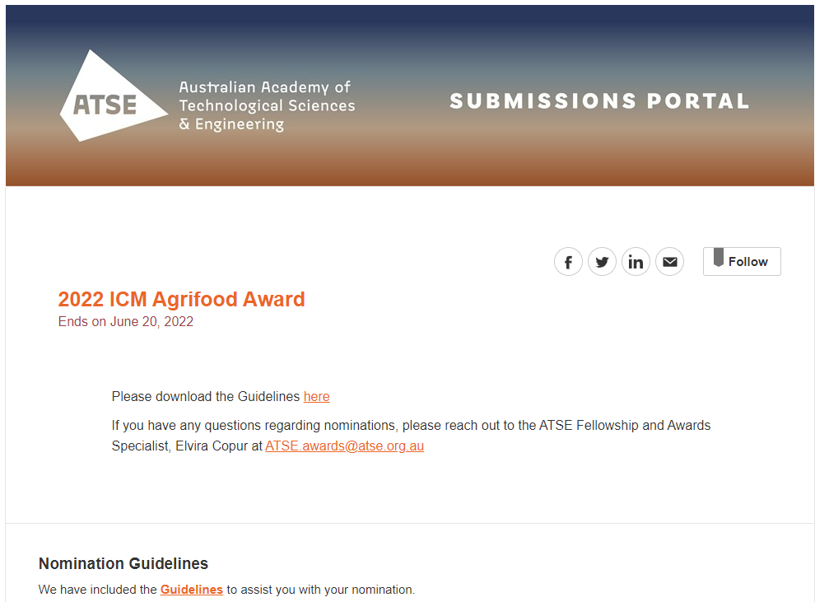
Proposer, Nominee and Seconder Details
Proposer Name
First Name

Last Name

Proposer Organisation

Proposer Position

Proposer Address

Country

Address

Address Line 2 (optional)

City

State

Postal Code

Proposer Email

Proposer Mobile Phone

Nominee Name
First Name

Last Name

Gender

Does the nominee identify as Aboriginal or Torres Strait Islander?
Nominee Date of Birth

Nominee Organisation

Nominee Position

Nominee Address

Country

Address

Address Line 2 (optional)

City

State

Postal Code

Nominee Email

Nominee Mobile Phone

Seconder Name
First Name

Last Name

Seconder Organisation
Seconder Position

Seconder Email

Seconder Mobile Phone

PART B: APPLICATION EXECUTIVE OVERVIEW – Limit 80 words
(for Citation purposes: please use plain English suitable for a broad audience)

PART C: AWARD SELECTION CRITERIA

Selection Criterion 1: Excellence in innovation and impact in a field related to food and agriculture in Australia - Limit 200 words

Selection Criterion 2: Peer acknowledgement of outstanding contributions to food and agriculture in the past five years – Limit 200 words

Selection Criterion 3: Advanced the standing of the broad profession of agriculture and food – Limit 200 words

PART D: PROPOSER STATEMENT
Why is the nominee worthy of the ICM Agrifood Award in terms of the selection criteria. – Limit 200 words

PART E: SECONDER STATEMENT
The Seconder is to provide a statement clearly indicating their detailed knowledge of the work for which the nomination has been made. The Seconder should be an industry or technical expert in the nominee’s field who can comment on the nominee’s signature contribution to the field. It is strongly encouraged that Seconders not be the nominee’s direct supervisor or manager.

PART F: NOMINEE STATEMENT OF CONSENT
The nominee has read the terms and conditions for the ATSE Awards and agree that, as a condition of them being nominated, they permit the release of all materials that I have submitted for the purposes of the selection process.
Furthermore, in the event of their receipt of the ATSE Award, they agree to:
• Attend the award ceremony in 2022 (details to be advised)
• Participate in activities as reasonably requested by ATSE within 12 months of receiving the award.
• Work with ATSE secretariat and Fellows to promote the importance of the award.
They also understand that in the event of being awarded the Award, a description of the work being acclaimed and images of themselves will be publicised, and they may be called upon to speak at events or to the media.

Nominations close 5pm AEST Monday 20 June 2022.
If you have any questions regarding the process, please don't hesitate to reach out to Elvira, Fellowship and Awards Specialist at atse.awards@atse.org.au

