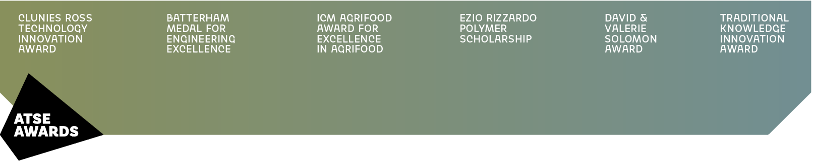

ATSE Awards 2024

Copy for posts on social media

OPTION 1
Do you know an innovator in applied science, technology or engineering? 🔬
Nominate them for the prestigious 2024 ATSE Awards and recognise their work! 🏆
🔗 Visit atse.org.au/awards to submit your nomination and celebrate excellence.
#ATSEAwards <tag ATSE>

OPTION 2
📢 Call for Award nominations!
Do you know an early-career engineer or innovator who's making waves in STEM? 🔬
🏆 Nominate them now for the prestigious ATSE Awards!
🔗 Visit atse.org.au/awards to nominate.
#ATSEAwards <tag ATSE>

OPTION 3
Do you know someone whose work in STEM has made a significant impact? 🔬
Now's the time to acknowledge their innovation! 🚀
🔗 Visit atse.org.au/awards to submit your nomination and recognise those whose contributions are shaping a brighter future.
#ATSEAwards <tag ATSE>

DOWNLOAD IMAGE TILES
www.atse.org.au/ATSE-Awards-2024-share

QUERIES
Queries about promoting the Awards: communications@atse.org.au
Queries about nominations: membership@atse.org.au

